Download and run GoogleCloudSDKInstaller.exe

<https://cloud.google.com/sdk/docs/install>

You will get this

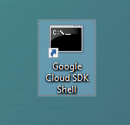

**Gcloud init**

**See also** [**https://cloud.google.com/sdk/docs/cheatsheet**](https://cloud.google.com/sdk/docs/cheatsheet)

[**https://cloud.google.com/static/sdk/docs/images/gcloud-cheat-sheet.pdf**](https://cloud.google.com/static/sdk/docs/images/gcloud-cheat-sheet.pdf)

**Gcloud info**

